**Walking RI:**

**The electrifying past of Glocester's Hawkins Pond**

***Go for a power walk on looping trails around this beautiful 10-acre pond, which once powered two mills and kept the lights on in small parts of neighboring communities.***

**John Kostrzewa**

Guest columnist

[**View Comments**](https://cm.providencejournal.com/comment/?storyUrl=https%3A%2F%2Fwww.providencejournal.com%2Fstory%2Flifestyle%2Ftravel%2F2021%2F06%2F30%2Fwalking-ri-beautiful-hawkins-pond-once-powered-mills-and-households-in-parts-of-glocester%2F7780578002%2F&marketName=providencejournal&commentsopen=false)

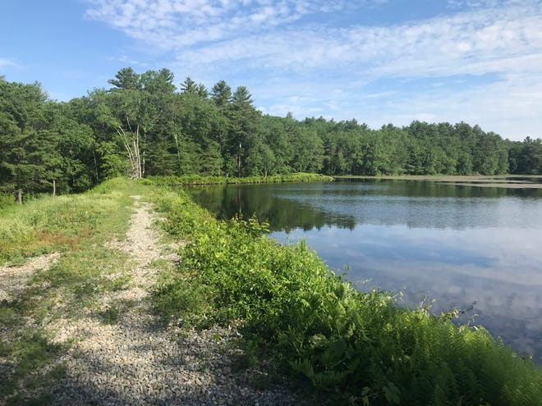

* Access: Head west on Route 44 from Chepachet. Drive about six miles and the trailhead is on the right, just before the state line.
* Parking: Available at two small lots.
* Dogs: Allowed, but must be kept on a leash.
* Difficulty: East, flat, loop trails.

GLOCESTER — Walter Hawkins was an entrepreneur who learned from his ancestors that water power could be harnessed to cut lumber and run woodworking mills.

Hawkins, a self-taught mechanic, installed a generator below a spillway from a man-made pond in 1912 and created electricity to light his house and later small parts of West Glocester and nearby Connecticut. The system was sold to Narragansett Electric in the 1930s.

Today, [Hawkins Pond](https://goo.gl/maps/PtNRFAKqhKJZoMQs5)bears his family’s name, and it's the center of three short, forested loop trails. The [Glocester Land Trust](https://www.glocesterlandtrust.org/properties/hawkins-pond" \t "_blank)acquired much of the property in 1993 from a member of the Hawkins family and last month dedicated the blazed trails.

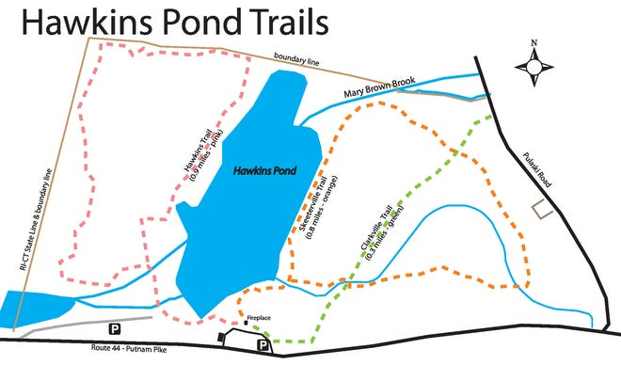

**Walking RI:**[Bay views and WWII history at Beavertail State Park](https://www.providencejournal.com/story/lifestyle/travel/2021/06/25/walking-ri-water-views-and-secret-wwii-history-beavertail-state-park-in-jamestown/7750595002/" \t "_blank)

**Walking RI:**[Hunt for RI's rare state rock at Cumberland's Blackall/Ballou Preserve](https://www.providencejournal.com/story/lifestyle/travel/2021/06/11/walking-ri-hunt-ris-rare-state-rock-while-hiking-cumberland/7615021002/" \t "_blank)

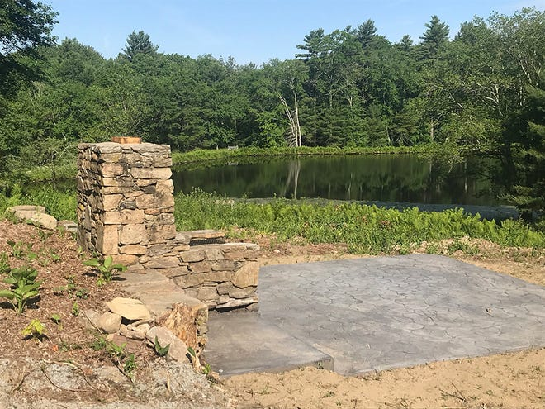

The 75-acre preserve abuts Pulaski Park, a part of the 4,000-acre George Washington Management Area. Just to the north is Buck Hill State Management Area. Local conservationists hope that together, the area may be large enough to apply for National Wilderness status, a prestigious federal designation for such a small state.

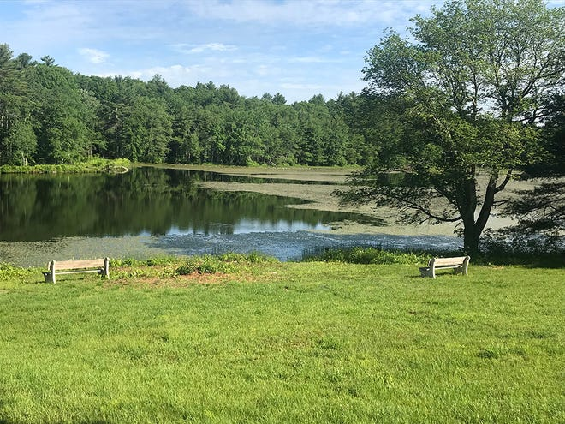

I set out  from a small parking lot off Putnam Pike. There’s a fireplace and stone terrace near the trailhead on a grassy hillside, and to the north you can see a long earthen dam that holds back a quiet 10-acre pond. Just below the dam are the remains of the old mills, including some of the stone walls, brick window casings and concrete floors.

Walter Hawkins’ father, Allen, built the dam to create the waterflow to run the family’s mill that cut lumber and turned out a variety of wood products.

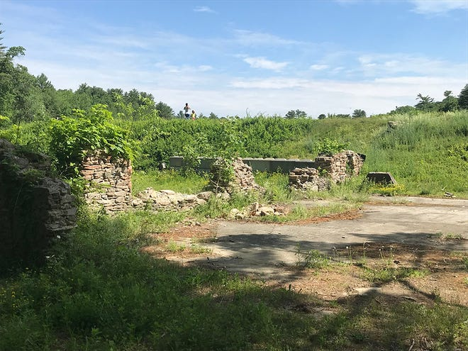

I walked a hundred yards along the top of the manmade dike to a lovely 15-foot terraced, smooth-stone waterfall. Benches along the top of the dike offered views of the lily-pad-covered pond that locals considered to be a good fishing spot.

**Walking RI:**[A mystery set in stone at Coventry's Parker Woodland Wildlife Refuge](https://www.providencejournal.com/story/lifestyle/travel/2021/06/18/origin-of-stone-cairns-is-mystery-at-coventry-ri-parker-woodland-wildlife-refuge/7673325002/" \t "_blank)

**Get out:**[From beaches to trails, there's plenty to do in RI this summer](https://www.providencejournal.com/story/lifestyle/travel/2021/06/04/things-to-do-rhode-island-summer-2021/7543114002/" \t "_blank)

From there, I walked down the impoundment and picked up the fern-covered, pink-blazed trail that hugs the pond before heading west into the woods under tall pines to the border with Connecticut. It circled back across stone walls to a stream that empties from the waterfall and eventually forms another small pond at the state border.

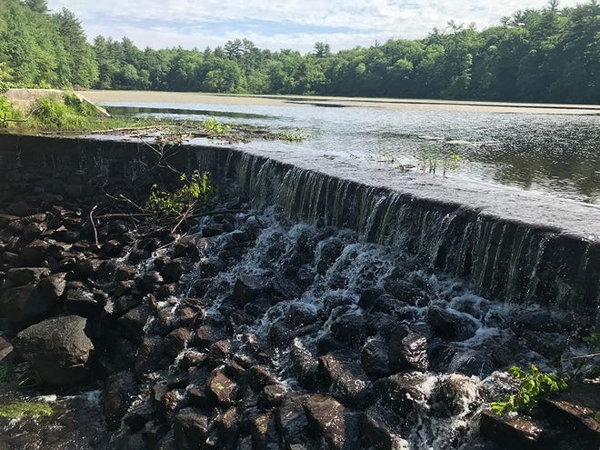

Back at the trailhead, I walked north on the orange trail that crossed a brook and edged the east side of the water before reaching Mary Brown Brook, which feeds the pond and was named for a woman who lived in the woods there in the 1880s.

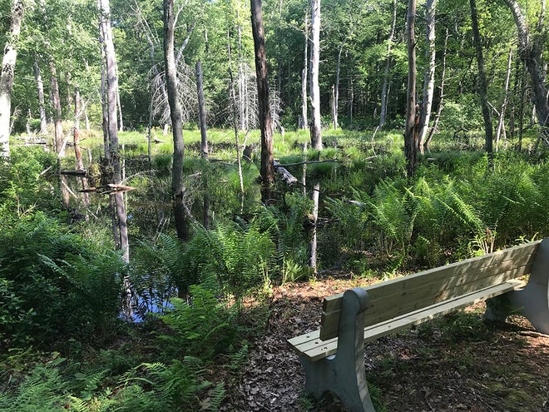

Upstream, beavers have built a dam, creating a large pool. There’s a bench to look for the beavers and other wildlife and waterfowl. Hikers report the preserve attracts pheasant, turkeys, deer, fox, coyotes, porcupines, raccoons, muskrats, woodchucks and opossum. Fishermen say the otters have reduced the number of fish in the pond.

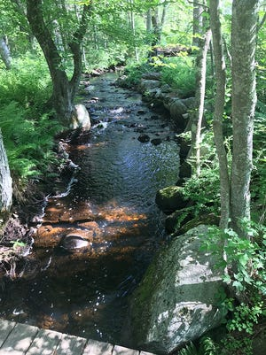

At this point, the trail turned east up a ridge and crosses the green-blazed trail on the right before looping back toward the trailhead. I passed a toppled telephone pole with transformers that once carried electricity to Clarkville and houses along Pulaski Road. There’s also an old wooden shed where the laborers at the mill took shelter.

The trail then crosses a series of small dikes built on streams before rising gently along a ridgeline and returning to where I started.

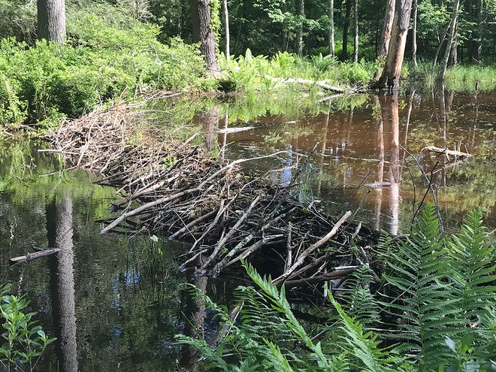

In all, I hiked about three miles for about 90 minutes, including a mile on the pink trail, 0.8 miles on the orange trail, a short hop on the green trail and other wanderings along and around the dike.

**Walking RI:**[Cultural connections on a Berkshires road trip](https://www.providencejournal.com/story/lifestyle/travel/2021/06/02/walking-ri-quick-hop-into-berkshires-trio-hikes-natural-bridge-state-park-pontoosuc-lake-mass-moca/5287719001/" \t "_blank)

**Walking RI:**[Hollywood wow factor on Hopkinton trail](https://www.providencejournal.com/story/lifestyle/travel/2021/04/30/walking-ri-hollywood-wow-factor-hopkinton-hike/7386164002/)

As I was leaving, a mother and a young girl arrived for a walk along the top of the earthen dam. The mom told me her daughter liked to explore. I replied that she had found the right place.

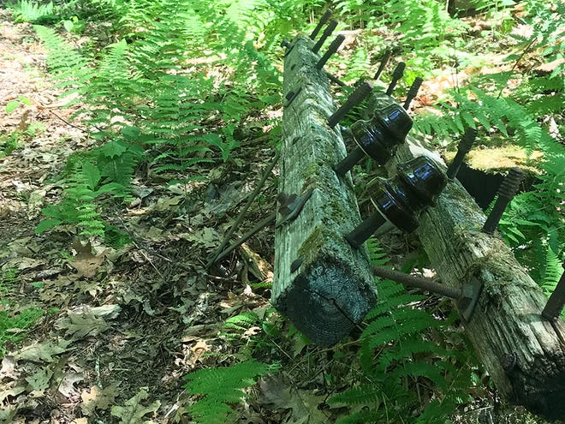

**Trail tip: Preventing tick bites**

* Avoid tick-infested areas, such as tall grass, by walking in the center of trails.
* Tuck pant legs into socks so ticks can’t get inside.
* Wear light-colored clothing.
* Cover as much of your skin as possible.
* Put on repellent, especially around ankles, wrists and exposed skin.
* After a hike, inspect ankles, behind knees, under arms, in and around ears, and in and around hair.
* Check boots, socks and clothing to avoid bringing ticks into the house.

